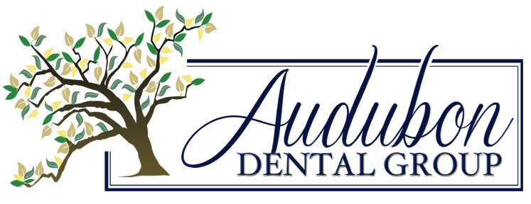
6120 Magazine St.
New Orleans, LA 70118-5826
p. 504-891-7471
f. 504-891-8919
www.AudubonDentalGroup.com

Authorization for Forwarding of Dental Records and Radiographs

Dear ________________________________,

The patient described below has requested that your office forward his or her dental records and any radiographs to our office.

Patient’s Name ___________________________________

Date of Birth ___________________________________

Patient’s Scheduled Appointment __________________________________

________________________________ ___________________________
Patient’s Signature Date

